**Saline bottle level monitoring system**

1Hitesh Patil**,** 2Pratham Patil, 3Rahul Ramane,4Ujjwal Shirode

1Electronics and Telecommunications department ,Pimpri Chinchwad College of Engineering,Pune

2Electronics and Telecommunications department ,Pimpri Chinchwad College of Engineering,Pune

3Electronics and Telecommunications department ,Pimpri Chinchwad College of Engineering,Pune

4Electronics and Telecommunications department ,Pimpri Chinchwad College of Engineering,Pune

ahitesh2432002patil@gmail.com,bpatilpratham359@gmail.com,crahulramane1312@gmail.com,dujjwal.shirode@pccoepune.org

**Abstract**

There are various implementations of saline bottle level monitoring systems. Nowadays there is rapid progress in medical care due to the technological advancements in the various fields

of microcontrollers, computers and sensors for assuring fast recovery of patients in the hospital. From various treatments, saline therapy is the most important treatment that many patients receive

from the hospitals in day to day life. This paper presents the planning and construction of level detecting mechanisms attached to saline bottles and are supported by ESP8266 and HX711. The mechanism monitors the level of saline bottle by detecting it through a load cell, which will find the difference of change in weight. Once approaching a precise distance, the HX711 and ESP8266 can send a message on the user's mobile phone and simultaneously a buzzer is used to alert surrounding people. Its small size, low cost, and reduced maintenance requirements are key features of this mechanism. The proposed work can be implemented in any hospital and can be easy for doctors as well as nurses to monitor the saline level. Throughout the document completely different needs of each hardware and computer code for the mechanism operation square measure explained, the proposed style is conferred and at last results and conclusions are shown.

**Keywords:**Saline level;Load-cell;Automation;Monitoring;mobile control,ThingESP,Twilio;

**Introduction**

According to the most recent study from the Global Health Observatory (GHO) on data on the density of doctors per population, there are less than 1 doctor for every 1000 people worldwide. To make care accessible, it is necessary to build smart healthcare systems that include telehealth. Automating diagnosis, treatment, management, and decision-making processes is necessary to transform the healthcare system into a smart one that provides services to both rural and urban residents.

Continuous monitoring is needed for this process. The drip chamber is used to modify the saline drop rate. It provides the patient's body with the appropriate amount of the solution. Whenever a saline drip occurs, A person must keep an eye on both the glucose level and the glucose flow rate on a frequent basis. The patient who is worried should be under close supervision.Here, the nurses or doctors should regularly check the patient's saline fluid level because there are two possible outcomes: either the blood may flow backward from the patient's body to the saline bottle due to low pressure in the bottle and high pressure of blood flowing in the patient's body, or there is a chance that air from the salinity will enter the saline bottle as air bubbles.The patient should be continually under the care of the nurses and doctors to avoid this harmful condition. Due to their busy schedules, nurses and doctors may have difficulty in this pandemic circumstance also.

Monitoring the saline level is one of the significant difficulties in managing healthcare. In almost all hospitals, a nurse or caretaker is in charge of monitoring the saline level, and if they don't, the patient suffers. When a saline bottle is empty and the needle is still in the patient's vein, the pressure differential causes the blood to flow outside into the bottle, which could seriously injure someone. In order to avoid such an accident, surveillance must be automated. Furthermore, telehealth services must provide long-distance clinical monitoring.Thus, an automated system of monitoring saline fluid is suggested in this study in order to save the patient's life and, in addition, to decrease the frequency of fluid monitoring in hospitals where there are many patients assigned to a small number of nurses.

M.M.A. Hashem developed an infrared technology-based device to detect heart rate and used a straightforward temperature sensor to determine body temperature. A remote communication was used to deliver data to the PC via the serial port.[1] The information was then transferred to the web server using the internet at that point. Additionally, it can be observed beginning anywhere in the web programme. The disadvantage of this developed strategy is that it needs a PC to deliver data to the web server via the internet.by Salman Ahmed A system has been developed in which the patient's body temperature, heart rate, and ECG are wirelessly transmitted via Bluetooth technology. In the proposed system, the hospital's monitoring center receives an SMS alert from the data collecting system via wireless ZigBee communication. method.

Many authors have addressed the above-discussed problem with IR sensors. When liquid comes close to the sensor, the infrared light from the LED reflects off of the liquid and is detected by the receiver. Due to labeling or covering on saline bottles, sometimes IR sensors fail to detect the exact level of saline.[2][3] It also happens if the bottle is tilted by some angle. A load cell and ESP8266 based system is perfect for such an innovative health management system as it overcomes limitations of previously proposed systems.Due to its accuracy and reliability, every hospital may easily and quickly install this system, which will assist the nurses and doctors in effectively monitoring the saline flow in the facilities.

In a study, Aruna P Phatale and colleagues made use of an Atmega 328 and Ir sensor to detect the level of saline bottle. It can wirelessly send the data to nurses or doctors computers and display the results in the form of saline droplet rate and no. Of droplets coming from saline bottles. The system is reliable and can be reused for the next saline bottle.[4]Mr. Jayant Ingle designed the entire idea using a load cell and arduino. The manual effort on the part of the nurses is saved from the alerting system and notifications. [5]Ankita Sapnare and colleagues designed a system which can monitor the amount of saline even in the control room using an application i.e Blynk app.The load sensor senses the weight at regular intervals and notification is send to the respective authorities.[6]

**Methodology**

In this section of paper discussion is done about working of some of the existing systems and working of this system.First discussion is done about the working of existing systems and noted down some of the flaws in order to address how this method improves on those flaws and in addition to that some new features are added.Existing work uses IR sensor in order to tack the flow of saline fluid but problem with that is there is a need to add heavier and complex hardware to the saline stand and we have to remove it and add it back when changing the saline bottle making it hard to work with[7].The other issue which comes with these systems is that IR sensor can be blocked by the labels present on saline bottle resulting in false triggering and not being able to work at all[8][9].

**System Design**

This system uses a 5Kg load cell to measure the weight of saline bottle as the density of saline bottle is approximately 1 thus making 500ml of fluid equivalent to 500 gm, output of this load cell is very low and is not measurable and needs to be converted to digital output to achieve this system uses a HX711 10 bit ADC and amplifier module, which is then given to ESP8266 where this level is compared with three levels given in table below. When the level is below 150 gm it uses ThingESP API to send a web request to it and to trigger Twilio whatsapp messaging system and to send sms to a previously set number in Twilio.

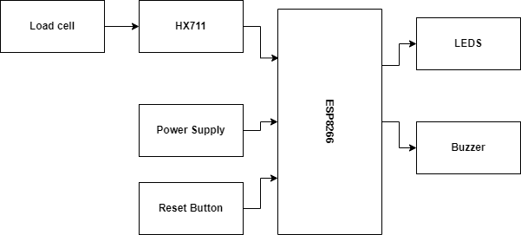

Fig.1 Block Diagram of Automatic Saline level Monitoring System

Power supply is taken using a 5v micro-USB to power ESP8266 where a recycled charger is being used . System has a 5V passive buzzer driven by 3.3V output of ESP8266 and red,yellow and green LED’s.

**Working**

When a new bottle of saline needs to be attached it is needed to press the reset button and wait for 1 min in order to calibrate load cell to zero and for it connect to wifi previously set which also increases the security for the device as no one can use this device without the authorized device hotspot being around. After calibration, esp8266 starts measuring the weight and compares it with all three conditions to check what is saline level and to figure out what next action should be taken.If it is low then it starts a buzzer, red led and triggers ThingESP API to send a web request to Twilio cloud and messaging system this sends message to preset mobile number through whatsapp because it increases the odds that the supervisor looking at the hospital room can notice that.So that they can change assist the patient and change the saline bottle.

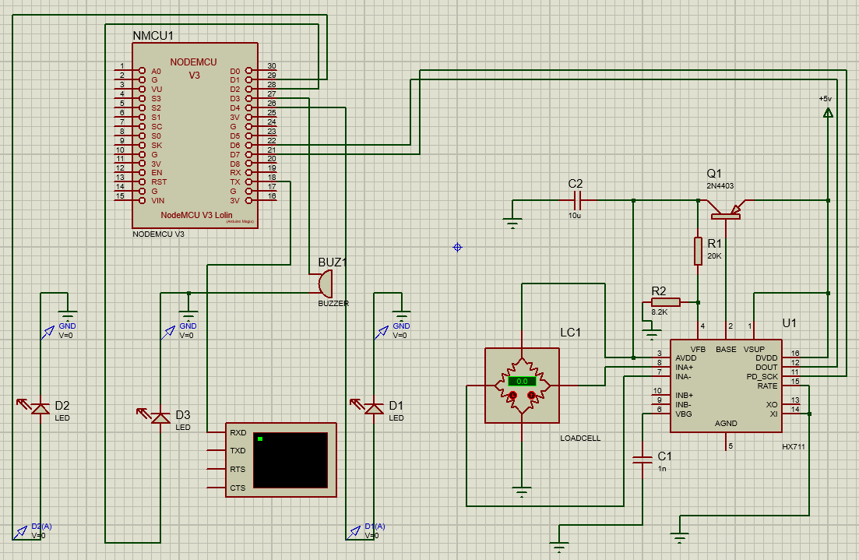

Fig.2 Simulation and circuit diagram of automatic saline monitoring system using Proteus software

Fig shows the simulation done on proteus for the same system and results are checked based on the leds and serial monitor output. Load cell reading was changed using the inbuilt buttons given with it and observation of weight was taken on serial monitor.

| Sr No. | Levels | Weight Range(in ml) |
| --- | --- | --- |
| 1 | HIGH | Weight >250 & weight<500 |
| 2 | Medium | Weight >150 & weight<250 |
| 3 | LOW | Weight >50 & weight<150 |

Table 1: Levels and their weight range for saline levels

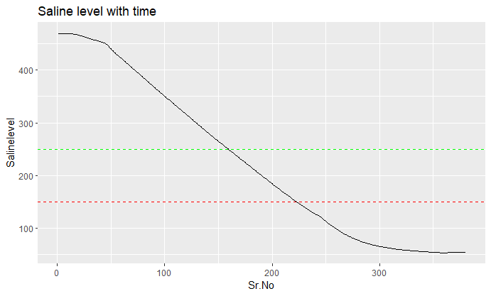

Fig.3 Graph of Saline level vs Time

This graph shows the live data taken from serial monitor of saline level while it is being used for the demonstration and yellow and red lines show the medium and low level where there will be triggering in logic level of pins based on table 2. It can be seen that the level of saline going down is a linear graph as the flow of saline while taking these observations.

**Results and Discussion**

The outcome of this work is the development of a saline monitoring system which detects the saline level and alerts the authority so that they can take further action and remove the saline in order to reduce cases of blood flowing back to the saline. The Whatsapp messaging system also makes sure that there is some official to attend the patient.

| Sensor Type | Measurement Minimum | Error Percentage |
| --- | --- | --- |
| IR distance | 2mm | 1.11 |
| Load Cell | 0.06gm | 0.12 |

Table2 : Error comparison in sensors

There is also a total of 4 mm error in IR sensor measurements ,whereas load cells can measure up to 0.06gm of weight accurately making it more effective in dealing with error as with every measurement it can generate error of 0.12%(In well calibrated scenario).Usage of esp8266 for messaging system instead of sim800l reduces the requirement of a physical sim card and a seperate data pack which increase reduces the maintenance cost furthermore while making it more practical in rural areas too.

**Conclusion**

This proposed work has reduced the chances of getting errors due to human intervention between the operations of saline level detection. It also reduces error due to usage of IR sensors as proposed work uses a Load cell paired with the HX711 module which has better error reduction. This system also reduces heavy dependence on hardware as very less amount of hardware is used which decreases chance of system breaking and causing error. Developed system uses very less power for transmission of the data too; the only dependence it has is on the mobile network/data to be present for the operation and to connect to ThingEsp API. Using an esp8266 message system rather than a sim800l lowers the need for a real sim card and a separate data pack, further lowering maintenance costs and improving its applicability in rural regions.

**References**

[1] M. M. A. Hashem, R. Shams, Md. A. Kader and A. Sayed,“Design and development of a heart rate measuring device using fingertip,” 3rd IEEE International Conference on Computer and Communication Engineering (ICCCE 10), Kuala Lumpur, Malaysia, May 11-12, 2010

[2] Pearline Sheeba P, Anushree N and Aishwarya L 2016 Saline Infusion Level Detection and Heart Rate Monitoring System International Journal for Research in Applied Science & Engineering Technology 4 637-641

[3] Yadav Shyama and Jain Preet 2016 International Conference on Control, Computing, Communication and Materials(ICCCCM) (Allahbad, India) Real time cost effective e-saline monitoring and control system 1-4

[4] Mansi G. Chidgopkar and Aruna P. Phatale IJRET: International Journal of Research in Engineering and Technology

[5] Mr. Jayant Ingale, Ms. Sharvari Sahare, Ms. Pradhnya Kanchane, Mr. Nikhil Tonge, Mr. Akshay Shah, Prof. Amar Banmare © 2021 IJCRT | Volume 9, Issue 5 May 2021

[6] Ankita Sapnar , Rutu Raka and Kshitij Malsane International Research Journal of Modernization in Engineering Technology and Science Volume:04/Issue:05/May-2022

[7] Ahmed, Salman, etal. "Wireless health monitoring system for patients." 2015 IEEEInternational WIE Conference on Elec- trical and Computer Engineering (WIECON-ECE). IEEE, 2015

[8] Mansi G. Chidgopkar ,Aruna P. Phatale: Automatic and low cost saline level monitoring system using wireless bluetooth module and CC2500 transceiver(: International Journal of Research in Engineering and Technology).

[9]Amey More , Darshan Bhor , Mihir Tilak , Dr. Gajanan Nagare: IoT based Smart Saline Bottle for Healthcare (International Journal of Engineering Research & Technology (IJERT),ISSN: 2278-0181,Vol. 10 Issue).